MODULE 3 WORKSHEET
Relationships between Variables

Purpose: You will be able to demonstrate a general understanding of interpreting statistical output to examine relationships between variables.
Instructions: Answer each item on this worksheet below and then upload this worksheet under the ASSIGNMENTS section in blackboard.

For Questions 1-7: A nurse on a busy pediatric unit noticed that her patients’ heart rates seem to be lower in the past few months since her unit hired a new music therapist. The previous music therapist would bring her amp with her into patients’ rooms and play her electric guitar LOUD. The previous music therapist left after many family complaints were filed against her. The new music therapist plays her acoustic guitar quietly in patients’ rooms and the patients seem much calmer and the nurse started to notice that the patients seem to have lower heart rates. The nurse was talking with her unit manager about this anecdotal observation and her manager encouraged her to search the literature to see if there is evidence supporting her hypothesis that the volume of music played in a patient’s room correlates to the patient’s heart rate. The nurse searched the literature with the help of the hospital librarians and found no evidence about this relationship. The unit manager thought the nurse was on to something and encouraged her to pursue this question through a unit-based research study. The nurse collaborated with a music therapist and a research mentor in the hospital, wrote a protocol, received IRB approval to conduct the study, and consented and enrolled 100 patients/families on her unit. For this study, she played music in each patient’s room and measured the volume of the music. The volume measurements ranged from 60 (soft music) to 95 (loud music). She recorded the volume of the music in the room and the infant’s heart rate at the end of 20 minutes of listening to data. Here is the SPSS output from his study:

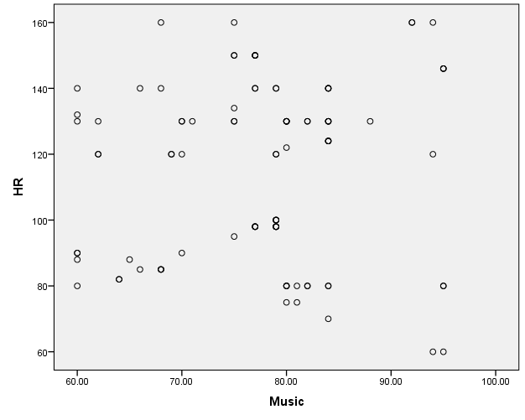

Descriptive Statistics
 | Mean | Std. Deviation | N
Music | 77.5600 | 9.30659 | 100
HR | 115.39 | 26.681 | 100

Correlations
 |  | Music | HR
Music | Pearson Correlation | 1 | .081
Music | Sig. (2-tailed) |  | .424
Music | N | 100 | 100
HR | Pearson Correlation | .081 | 1
HR | Sig. (2-tailed) | .424
HR | N | 100 | 100

- What was the mean volume of music played in the patients’ rooms? (2 points)

- What was the mean heart rate of the patients? (2 points)

- What is the null hypothesis being tested? (2 points)

- What is the correlation coefficient (r) from this analysis? (5 points)

- What is the p value from this analysis? (5 points)

- Would you reject or fail to reject the null hypothesis? (5 points)

- What conclusion would you make? (5 points)

For Questions 8-12: The nurse was frustrated with her results from the previous study (and she’d caught the research bug) so she met with the study team about replicating the study but this time measuring patient/family satisfaction instead of heart rate. She thought maybe the volume of music would relate to patient/family satisfaction. She received IRB approval for this new study, consented and enrolled another 100 patients, and used the same protocol of measuring music volume and then she added a satisfaction survey that patients/families completed at the end of their admission. The satisfaction survey was scored and satisfaction scores ranged from 0-100 and included any numbers in between (including fractions and decimal points). Here is the SPSS output from his study:

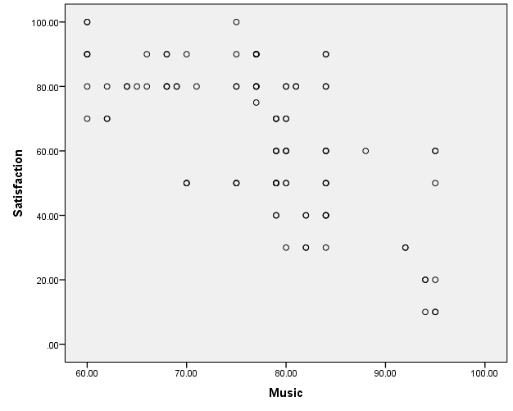
Descriptive Statistics
 | Mean | Std. Deviation | N
Music | 77.5600 | 9.30659 | 100
Satisfaction | 63.6500 | 22.51660 | 100

Correlations
 |  | Music | Satisfaction
Music | Pearson Correlation | 1 | -.661**
Music | Sig. (2-tailed) |  | .000
Music | N | 100 | 100
Satisfaction | Pearson Correlation | -.661** | 1
Satisfaction | Sig. (2-tailed) | .000
Satisfaction | N | 100 | 100
**. Correlation is significant at the 0.01 level (2-tailed).

- What was the mean satisfaction score? (2 points)

- What is the correlation coefficient (r) from this analysis? (5 points)

- What is the p value from this analysis? (5 points)

- Would you reject or fail to reject the null hypothesis? (5 points)

- What conclusion would you make? (5 points)

For Questions 13-16: The nurse was excited about these results and wanted to take her analysis a step further. She submitted an amendment to the IRB to allow for a new statistical analysis plan. Her statistician ran a linear regression. Here is the SPSS output:

Coefficientsª
Model |  | Unstandardized Coefficients |  | Standardized Coefficients | t | Sig.
 |  | B | Std. Error | Beta | t | Sig.
1 | (Constant) | 187.701 | 14.324 |  | 13.104 | .000
1 | Music | -1.599 | .183 | -.661 | -8.722 | .000
- What is the null hypothesis being tested? (2 points)

- What is the p value from this analysis? (5 points)

- Would you reject or fail to reject the null hypothesis? (5 points)

- What conclusion would you make? (5 points)

For Questions 17-18: The nurse presented her findings at a national conference and then published her results in a peer-reviewed academic nursing journal. A nurse at the adult hospital in town wondered if these findings could be translated to adult patients. Inspired by this other nurse, she decided to do a small scale study at her hospital. She partnered with others at her hospital, wrote a protocol, received IRB approval, and consented and enrolled 25 patients. She followed the same protocol and measured music volume, but she decided to create her own satisfaction survey that was less time consuming. She simply gave her patients a paper to fill out at discharge that asked one question:

How satisfied were you with your hospital stay?
- Very satisfied
- Somewhat satisfied
- Neutral
- Somewhat dissatisfied
- Very dissatisfied

She sent her data off to her statistician and here is the SPSS output she got back:
Correlations
 |  |  | Music | Satisfaction
Spearman's rho | Music | Correlation Coefficient | 1.000 | -.669**
Spearman's rho | Music | Sig. (2-tailed) | . | .000
Spearman's rho | Music | N | 25 | 25
Spearman's rho | Satisfaction | Correlation Coefficient | -.669** | 1.000
Spearman's rho | Satisfaction | Sig. (2-tailed) | .000 | .
Spearman's rho | Satisfaction | N | 25 | 25
**. Correlation is significant at the 0.01 level (2-tailed).

- She immediately sent an email back to the statistician and said there must be something wrong. She said that she replicated a published study and in that study, the results were reported as a Pearson Correlation. She asked that the statistician re-analyze the data using a Pearson correlation. Provide a response that the statistician may have provided that would explain her choice in statistical tests. (5 points)

- The nurse understood this explanation and realized the output above was the correct test. What conclusion did she make from this output? Did her study find similar results to the study she was replicating? (5 points)

Total = 75 points

MODULE 3 ACTIVITY
Correlation and Regression

Purpose: The purpose of this learning activity is to demonstrate the understanding of correlation and regression and how they could be important in your future practice.

Instructions: Go to ASSIGNMENTS in blackboard. Click on the underlined heading Module 3 Activity. Submit 1 paragraph answering the following questions:
- What are the differences between results that demonstrate a correlation between two variables and results where a regression is run using two variables?
- Think about your future clinical role and provide a clinical example of variables that you may want a correlation analysis run and explain.
- Think about your future clinical role and provide a clinical example of variables that you may want a regression analysis run and explain.

Note: My future clinical role: treating patients as an Adult Nurse Practitioner.

